Variable and Datatypes in Java

Variable is a name of memory location. There are three types of variables: local, instance and static. There are two types of datatypes in java, primitive and non-primitive.

Variable
Variable is name of reserved area allocated in memory.
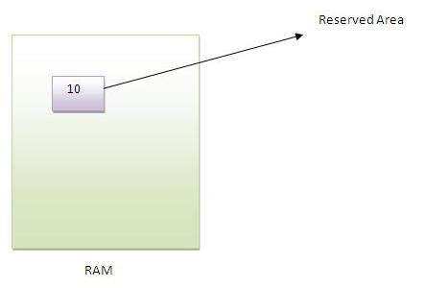

int data=50;//Here data is variable

Types of Variable
There are three types of variables in java
- local variable
- instance variable
- static variable
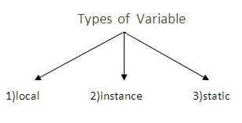

Local Variable
A variable that is declared inside the method is called local variable.

Instance Variable
A variable that is declared inside the class but outside the method is called instance variable . It is not declared as static.

Static variable
A variable that is declared as static is called static variable. It cannot be local.

We will have detailed learning of these variables in next chapters.

Example to understand the types of variables

class A{

int data=50;//instance variable

static int m=100;//static variable

void method(){
int n=90;//local variable
}

}//end of class

Data Types in Java
In java, there are two types of data types
- primitive data types
- non-primitive data types
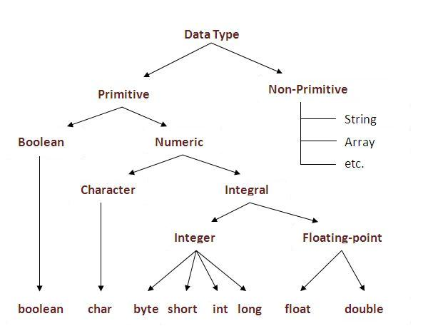
Data Type | Default Value | Default size
boolean | false | 1 bit
char | '\u0000' | 2 byte
byte | 0 | 1 byte
short | 0 | 2 byte
int | 0 | 4 byte
long | 0L | 8 byte
float | 0.0f | 4 byte
double | 0.0d | 8 byte

